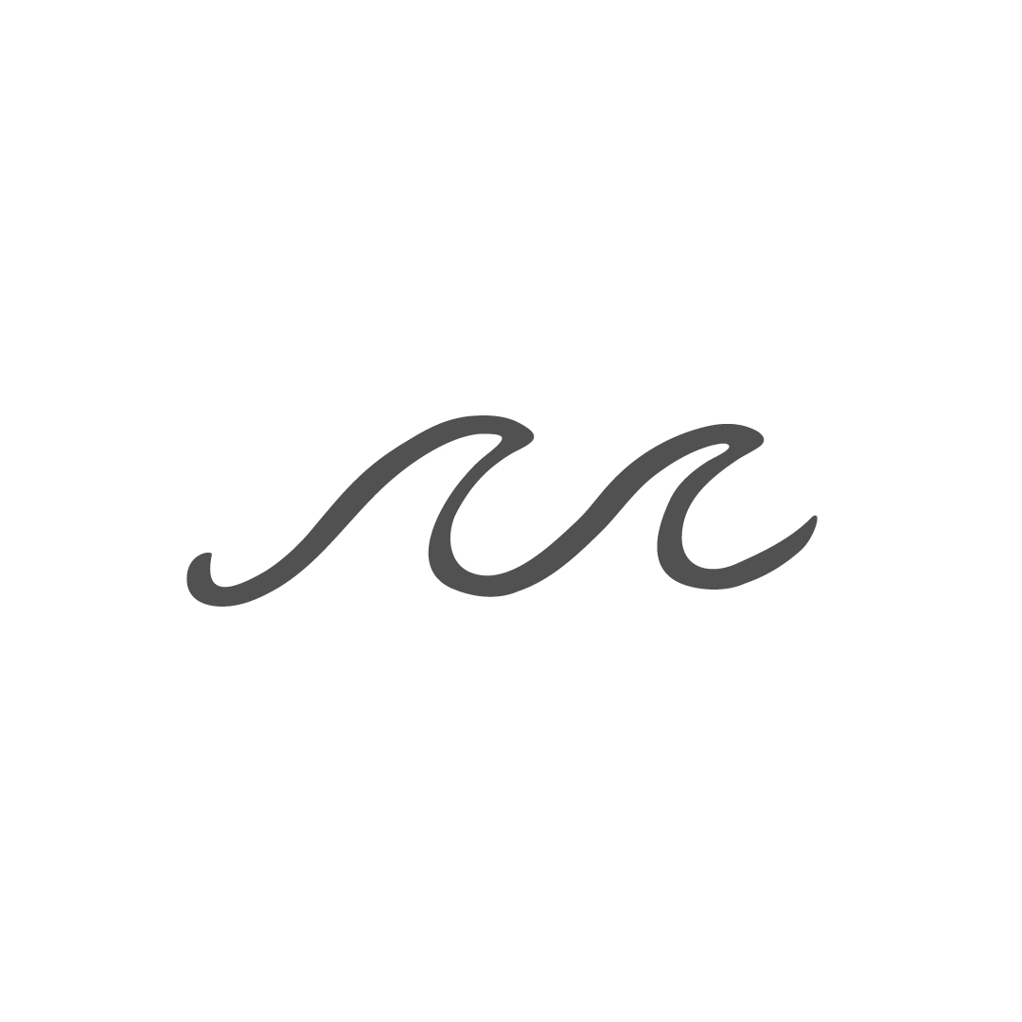

PARRYS ESTATE ACCOMMODATION BOOKINGS

TERMS AND CONDITIONS

Thank you for choosing Parrys Estate. We are committed to providing you with an exceptional experience. These Terms and Conditions apply to the hire of a Residence at Parrys Estate. We may update these terms from time to time to better serve you.

**Booking Procedure**

When you request to hire a Residence, we will make a tentative booking for you. This booking will be held without obligation and will be confirmed once we receive your payment within 24 hours. By making a payment, you agree to these terms and conditions.

**Security Bond**

We require your credit card information 30 days before your stay to cover any potential costs for damages or extra cleaning. Any unused amount will be refunded within seven days after your stay.

**Residence Hire Fee**

The full Residence Hire Fee must be paid when you book. Payment can be made by cash, bank transfer, or credit card.

**Use of the Estate**

Parrys Estate is a working farm and eco-sanctuary. We ask that you respect the property, animals, plants, and structures. Please do not leave rubbish or food anywhere on the Estate.

**Use of the Residence**

You are granted a license to use the Residence during your booking period. The maximum number of guests allowed is six. We provide all linen, including bed sheets and towels.

**Children**

Children sleeping in a porta cot are included in the maximum number of guests. Only one child in a porta cot is allowed per Residence.

**Arrival and Departure**

Check-in is from 3:00 pm, and check-out is by 10:00 am. Please ensure the Residence is left clean and tidy, with all refuse removed.

**Conduct at the Residence**

We ask that you carry out activities in a proper, orderly, and safe manner. Please comply with any directions given by Parrys Estate staff.

**Smoking**

Smoking is only permitted in designated areas. A fee of $500.00 will be charged for non-compliance.

**Lost Property**

Parrys Estate is not responsible for any damage, loss, theft, or removal of property brought to or left at the Estate.

**Parking**

Please ensure vehicles or bicycles do not obstruct entry, exit, or use of the Residence or Estate.

**Prohibited Items**

Prohibited items are not allowed on the Estate. We may remove any prohibited items or guests found in possession of them.

**Variations**

You may request to vary the date or period of your booking in writing. Requests must be received no later than 30 days before your stay. If the new dates are available, we will adjust the Residence Hire Fee accordingly.

**Cancellation by Client**

You may cancel your booking by providing written notice. If you cancel more than 30 days before your stay, you will receive a full refund. If you cancel within 30 days of your stay, no refund will be provided. This policy also applies to any variations on your booking.

**Cancellation by Parrys Estate**

We may cancel your booking due to unforeseen circumstances or if we believe you will not comply with these terms. In such cases, we will refund all monies paid within seven days.

**Coronavirus (COVID-19)**

Please comply with any directions or orders related to COVID-19. If you are unable to stay due to such orders, we will work with you to vary the date of your booking.

**Force Majeure**

If a Force Majeure Event prevents us from fulfilling our obligations, we may cancel your booking and refund all monies paid within seven days.

**Client’s Liability**

You are liable for any loss or damage caused by you or your guests. Please ensure compliance with these terms to avoid any additional charges.